Agile Group Project

Find New Recipes

By

Balraj Singh

Dilpreet Singh

Rahul Pandey

Contents

Introduction 3

Project Members 3

Agile Methodology 4

Pages and Mock-ups 5

Start 5

Home 5

Favourite List 6

Recipe Page 6

Internet Search Page 7

Conclusion 7

# Pages and Mock-ups

## Start

This is a landing page of the application which appears only for 3000mili seconds. It contains an image. After 3000 milliseconds, it reroutes to the home page.



## Home

This is the main page of the application. On this page there are four buttons search, like, dislike and favourite. Whenever user searches any recipes by adding the name of the recipe, the application will display all relevant recipes. If user likes any recipe and clicks on like button, it will be added to the favourite list and if user doesn’t like any recipe, it moves to the next one. Moreover, if user clicks on favourite button, he/she can route to the favourite page where they can access the list of their favourite recipes.

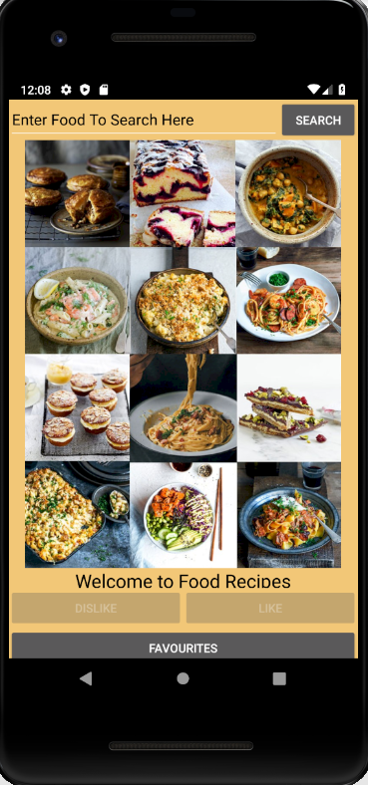 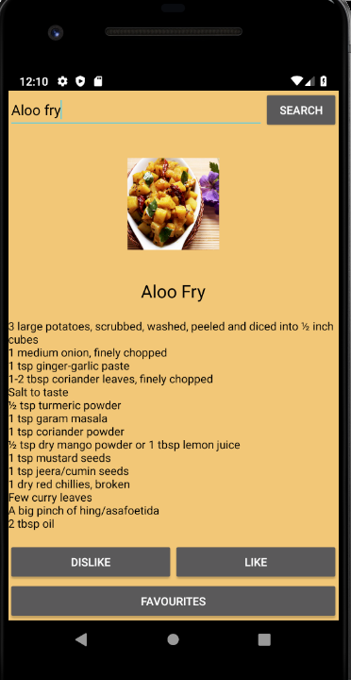

## Favourite List

On this page user can see the list of the recipes which they have liked on the home page. Also, when they will click on any recipe, recipe page will open.

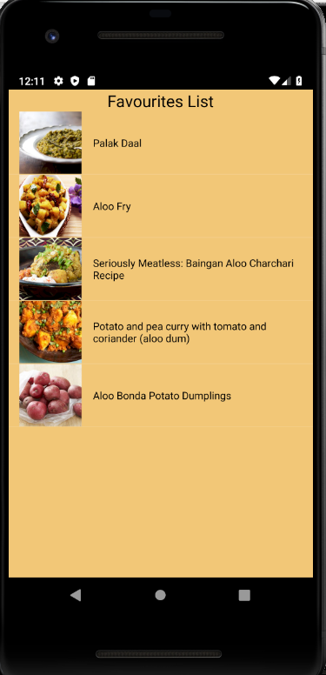

## Recipe Page

It will show the detailed recipe along with ingredient details and name of recipe. Here user can see GotoRecipe button, when user click on this button, the API will direct user to the root page of the recipe on internet.

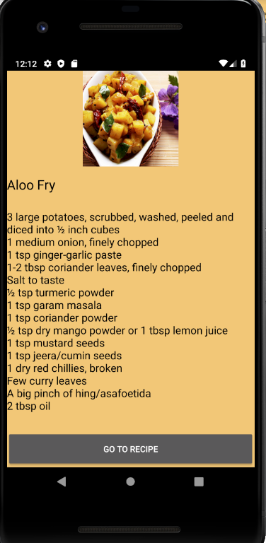

## Internet Search Page

When user click on Go to Recipe button on recipe page, food recipe app redirect user to the internet search page where user can find the details of that particular recipe.

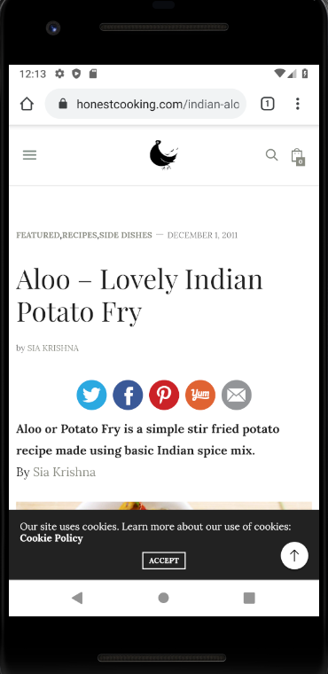

# Conclusion

In nutshell, this project is based on agile scrum methodology. Where IT team has designed an android application called find new recipes. In this project all team members contributed equally and collaboratively.